PROJECT REPORT

Health360
Comprehensive Healthcare Risk & Disease Analytics
Submitted by
ANANYA KOTASTHANE
Enrollment Number: EN25CS3010120
B.Tech – Computer Science Engineering
Medicaps University, Indore
Academic Year 2026 – 27

INDEX

1. INTRODUCTION 2
1.1 Project Overview 2
1.2 Purpose 3
2. IDEATION PHASE 4
2.1 Problem Statement 4
2.2 Empathy Map Canvas 5
2.3 Brainstorming 5
3. REQUIREMENT ANALYSIS 7
3.1 Customer Journey Map 7
3.2 Solution Requirement 7
3.3 Data Flow Diagram 8
3.4 Technology Stack 9
4. PROJECT DESIGN 11
4.1 Problem Solution Fit 11
4.2 Proposed Solution 11
4.3 Solution Architecture 13
5. PROJECT PLANNING & SCHEDULING 15
5.1 Project Planning 15
6. FUNCTIONAL AND PERFORMANCE TESTING 17
6.1 Performance Testing 17
7. RESULTS 19
7.1 Output Screenshots 19
8. ADVANTAGES & DISADVANTAGES 29
9. CONCLUSION 30
10. FUTURE SCOPE 31
11. APPENDIX 32
Source Code (if any) 32
Dataset Link 33
GitHub & Project Demo Link 33

1. INTRODUCTION

1.1 Project Overview
Health360: Comprehensive Healthcare Risk & Disease Analytics is a data analytics and visualisation project that studies how everyday lifestyle choices and measurable clinical indicators relate to three of the most common chronic conditions – diabetes, heart disease and stroke. The project converts a flat healthcare patient dataset into a fully interactive business-intelligence dashboard that a non-technical user can explore without writing a single query.
The dataset contains one record per patient. Each record carries demographic information (age), physical and clinical measurements (Body Mass Index and blood pressure), behavioural factors (alcohol consumption, smoking and exercise level), a symptom indicator (fatigue) and three outcome flags (diabetes, heart disease and stroke). Because raw numbers such as an age of 47 or a BMI of 27.3 are difficult to compare directly, the project engineers three derived categorical fields – Age Group, BMI Category and Exercise Level Category – that make patterns visible at a glance.
Using Tableau, the data is explored through nine purpose-built worksheets plus a KPI summary card. These are combined into a single dashboard titled “Smart Healthcare and Risk Factor Analysis Dashboard”, which is then published on Tableau Public and embedded into a Flask-based web application deployed on Render, so that it can be shared through a simple web link.

Key components of the project
- KPI Overview: headline counts for total patients, diabetes cases, heart-disease cases and stroke cases.
- Average Blood Pressure across Age Groups: shows how blood pressure changes as patients grow older.
- Alcohol and Smoking Consumption across Age Groups: compares two behavioural risk factors side by side for each age group.
- Exercise Level Distribution (donut chart): shows how the patient population is divided between sedentary and active lifestyles.
- Patient Distribution by Age Group (pie chart): shows the share of the population that falls in each age band.
- Heart Disease vs Diabetes Prevalence by BMI Category: compares absolute case counts of two diseases across weight categories.
- BMI Category vs Heart Disease Rate: shows the percentage of patients with heart disease inside each BMI category.
- Heart Disease by BMI Category and Exercise Level (heatmap): reveals the combined effect of body weight and physical activity.
- Age Group Distribution by Fatigue Condition: shows how fatigue is spread across age bands.
- Integrated dashboard: all sheets arranged on one canvas under a single title and published on the web.

Scope of the project
The scope covers data preparation, feature engineering, descriptive and comparative analysis, interactive visualisation, publishing and web embedding. It is a descriptive analytics project: it highlights where risk is concentrated in the patient population, but it does not diagnose individual patients or claim causation between a lifestyle factor and a disease.

1.2 Purpose
The purpose of Health360 is to turn healthcare data into decisions. Hospitals, public-health teams and students often hold large tables of patient information but lack a quick, visual way of seeing which groups of people are most exposed to chronic disease. This project provides that view.

Objectives
- To collect and understand a healthcare patient dataset and identify the variables that describe lifestyle, clinical condition and disease outcome.
- To engineer meaningful categories (Age Group, BMI Category, Exercise Level Category) from raw numerical columns using Tableau calculated fields.
- To analyse how blood pressure, alcohol consumption, smoking, exercise, BMI, age and fatigue vary across the patient population.
- To compare the prevalence of diabetes, heart disease and stroke across different risk-factor groups.
- To build an interactive dashboard with filters that lets users slice the data on their own.
- To publish the dashboard on Tableau Public and embed it in a Flask web application so that it is accessible from any browser.
- To document the complete life cycle of the project – ideation, requirements, design, planning, testing and results – in a standard report format.

Intended users
- Public-health officers and hospital administrators who need a quick view of the risk profile of their patient population.
- Doctors and medical students who want to see population-level patterns behind clinical guidelines.
- Data-analytics students who want a worked example of a complete Tableau project from raw data to a published dashboard.

2. IDEATION PHASE
The ideation phase captures the thinking that took place before any chart was built. It answers three questions: what problem are we solving, for whom, and what are the best ways of solving it?

2.1 Problem Statement
Chronic diseases such as diabetes, heart disease and stroke develop slowly and are strongly linked to modifiable factors – body weight, blood pressure, smoking, alcohol and physical inactivity. Healthcare organisations collect this information routinely, but it usually sits in spreadsheets or databases as thousands of rows. Reading these rows one by one does not tell a decision maker which age group, weight category or lifestyle group needs attention first.
The problem is therefore the lack of an easy-to-use, visual and interactive tool that summarises patient risk factors and disease prevalence in one place and lets users filter the data themselves.

Customer problem statement
I am | A healthcare analyst / public-health officer responsible for understanding the health risks of a patient population.
I am trying to | Identify which age groups, BMI categories and lifestyle groups have the highest burden of diabetes, heart disease and stroke.
But | The data is stored as large tables and I cannot quickly see patterns, compare groups or filter the data without technical skills.
Because | Raw numerical columns (age, BMI, blood pressure) are not grouped, there is no visual summary, and every new question needs a new query or spreadsheet formula.
Which makes me feel | Overloaded with data, uncertain about my conclusions, and slow to respond with preventive action.

Problem statements (PS)
PS | I am | I am trying to | But | Because | Which makes me feel
PS-1 | Public-health officer | Find the age groups most at risk | I cannot see age-wise patterns | Age is stored as a raw number | Unsure where to focus screening camps
PS-2 | Hospital analyst | Compare disease burden across BMI categories | Reports show only totals | BMI is not categorised | Unable to justify weight-management programmes
PS-3 | Medical student | Understand how lifestyle affects disease | Data is scattered across tables | No single visual summary exists | Confused and discouraged

2.2 Empathy Map Canvas
An empathy map was prepared for the primary user – a healthcare analyst who must present risk insights to management. It records what the user says, thinks, does and feels, together with their pains and gains, so that the dashboard is designed around real needs rather than assumptions.
Says | “Which group should we target first?”  “I need a quick summary for the meeting.”  “Can I filter this by BMI or age?”
Thinks | Is the data telling me something I am missing?  Will management trust a spreadsheet full of numbers?  There must be a faster way to compare groups.
Does | Exports data to spreadsheets and builds pivot tables manually.  Copies charts into slides.  Asks colleagues for help with queries.
Feels | Pressured by deadlines.  Anxious about missing high-risk groups.  Motivated when insights are clear and visual.
Pains | Time-consuming manual analysis.  Static reports that cannot be filtered.  Difficulty explaining numbers to non-technical audiences.
Gains | One interactive dashboard for all questions.  Clear colours, labels and filters.  Shareable link that works in any browser.

2.3 Brainstorming
A brainstorming session was held to generate as many solution ideas as possible before choosing one. Ideas were listed freely, grouped into themes and then scored on feasibility, impact and effort.

Ideas generated
- A spreadsheet with conditional formatting and pivot tables.
- A Python (pandas + matplotlib) notebook with static charts.
- A Power BI report.
- A Tableau dashboard with calculated fields, KPI card and filters.
- A machine-learning model that predicts disease risk for an individual.
- A web application that embeds the published dashboard for easy sharing.

Idea prioritisation
Idea | Feasibility | Impact | Effort | Decision
Spreadsheet pivot tables | High | Low | Low | Rejected – not interactive enough
Python static charts | High | Medium | Medium | Rejected – no filters, hard to share
Power BI report | High | High | Medium | Alternative
Tableau dashboard | High | High | Medium | Selected
ML risk-prediction model | Medium | High | High | Moved to future scope
Flask web embedding | High | Medium | Low | Selected (delivery layer)

Tableau was selected because it supports drag-and-drop analysis, calculated fields, dual-axis charts, heatmaps, dashboard filters and free publishing through Tableau Public. A Flask web application was added as a delivery layer so that the dashboard can be presented inside a custom web page.

3. REQUIREMENT ANALYSIS
Requirement analysis converts the ideas from the ideation phase into concrete, testable requirements for the data, the visualisations and the technology.

3.1 Customer Journey Map
The journey map follows the analyst from the moment a question arises to the moment an action is taken, showing where the dashboard helps at each stage.
Stage | User actions | Touchpoints | Experience | Pain points | Opportunity
Awareness | Receives a request to report on patient risk | Email, meeting | Neutral | Unclear where to start | Share the dashboard link
Access | Opens the Flask page / Tableau Public link | Web browser | Positive | Tools needing installation | Browser-only access, no install
Explore | Reads the KPI card and charts; applies filters | Dashboard, filters | Curious, engaged | Too many numbers in tables | Colour, labels and filters
Insight | Spots high-risk age/BMI/lifestyle groups | Heatmap, bar and pie charts | Confident | Interpreting the combined effect of factors | Heatmap with two dimensions
Action | Prepares recommendations and screening plans | Slides, reports | Satisfied | Re-creating charts manually | Download image / PDF from Tableau

3.2 Solution Requirement

Functional requirements
ID | Requirement | Description
FR-1 | Data import | The system shall load the healthcare dataset (CSV/Excel) into Tableau as a data source.
FR-2 | Calculated fields | The system shall create Age Group, BMI Category and Exercise Level Category from raw columns.
FR-3 | KPI summary | The dashboard shall display total patients and the total number of diabetes, heart-disease and stroke cases.
FR-4 | Risk-factor charts | The dashboard shall visualise blood pressure, alcohol, smoking, exercise, age and fatigue distributions.
FR-5 | Disease analysis | The dashboard shall show disease prevalence and disease rate by BMI category and exercise level.
FR-6 | Interactivity | Users shall be able to filter by BMI Category, Age Group and Fatigue; filters shall apply to all sheets using the same data source.
FR-7 | Publishing | The workbook shall be published to Tableau Public and produce a shareable URL.
FR-8 | Web embedding | The published dashboard shall be embedded in a Flask web page.

Non-functional requirements
ID | Requirement | Description
NFR-1 | Usability | A user with no technical background shall be able to understand each chart from its title, colours and labels.
NFR-2 | Performance | Charts and filters shall respond within a few seconds on a standard laptop and broadband connection.
NFR-3 | Accuracy | Aggregations (COUNT, SUM, AVG) shall match the values calculated directly from the dataset.
NFR-4 | Portability | The dashboard shall be viewable on any modern browser without installing software.
NFR-5 | Privacy | The dataset shall not contain names, phone numbers or any directly identifying information.
NFR-6 | Maintainability | Calculated fields and sheets shall be named clearly so that they can be updated when the data changes.

3.3 Data Flow Diagram
The data flow diagrams describe how information moves through the Health360 system. The Level 0 (context) diagram treats the whole project as a single process, with the dataset as input and users as the receivers of insights.
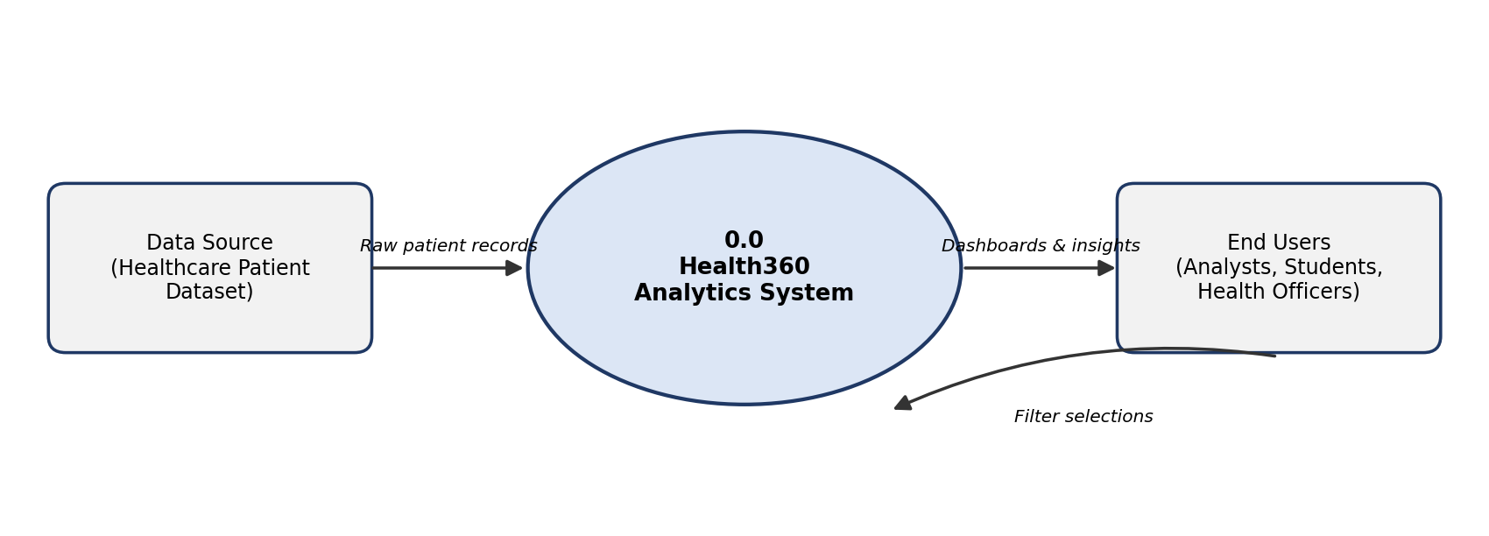
Figure 3.1: Data Flow Diagram – Level 0
The Level 1 diagram breaks the system into six processes and two data stores:
- Process 1.0 – Data Import & Cleaning: the dataset is loaded into Tableau, data types are checked and missing or inconsistent values are handled.
- Process 2.0 – Feature Engineering: calculated fields for Age Group, BMI Category and Exercise Level Category are created and stored in the data source (D1).
- Process 3.0 – Worksheet Creation: nine worksheets and the KPI card are created from the enriched data.
- Process 4.0 – Dashboard Assembly & Filters: worksheets are arranged on the dashboard and global filters are configured; the result is stored in the Tableau workbook (D2).
- Process 5.0 – Publish to Tableau Public: the workbook is saved to Tableau Public and a public URL is generated.
- Process 6.0 – Embed in Flask: the embed code is placed in an HTML template served by Flask, from where end users view the dashboard in a browser.
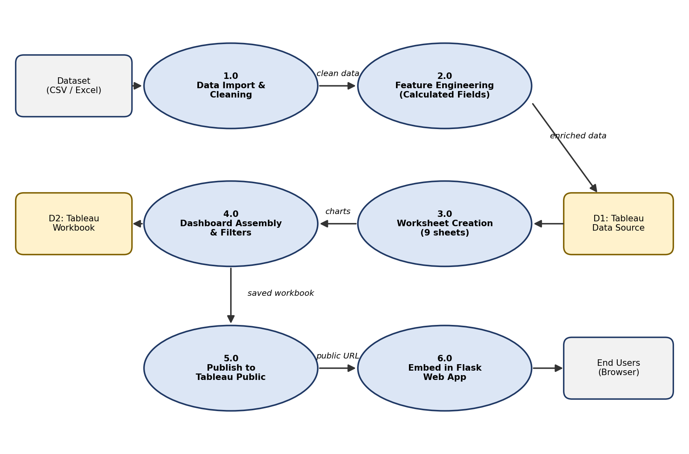
Figure 3.2: Data Flow Diagram – Level 1

3.4 Technology Stack
Layer | Technology | Purpose
Data | CSV / Excel dataset | Stores patient-level records.
Analytics & visualisation | Tableau Desktop | Data connection, calculated fields, worksheets, dashboard design.
Publishing | Tableau Public | Free cloud hosting of the finished dashboard and generation of embed code.
Web application | Python 3 with Flask | Lightweight web server that renders the page containing the dashboard.
Front end | HTML5, CSS3 | Page layout, styling and the embedded Tableau viewer.
Hosting | Render | Cloud hosting of the Flask web application at a public URL.
Version control | Git and GitHub | Source-code storage, versioning and sharing of the project.
Documentation | Microsoft Word / Google Docs | Preparation of this project report.

4. PROJECT DESIGN

4.1 Problem Solution Fit
The problem–solution fit checks whether the proposed solution genuinely matches the problem faced by the users. The table below maps each pain of the target user with the feature of Health360 that addresses it.
User problem | Health360 feature | Fit
Data is a large table; patterns are not visible | Visual charts with colour and labels | Patterns are visible at a glance
Age, BMI and exercise are raw numbers | Calculated fields create categories | Groups can be compared directly
Different questions need different reports | Interactive filters on the dashboard | One dashboard answers many questions
Hard to see overall disease burden | KPI card with totals | Instant headline numbers
Combined effect of two factors is unclear | BMI × Exercise heatmap | Highlights the riskiest combinations
Sharing reports is slow | Tableau Public link and Flask page | Anyone with a browser can view

Customer segments and channels
- Segments: hospital management, public-health departments, medical and data-science students.
- Channels: web page (Flask), Tableau Public link, exported images/PDF for presentations.
- Triggers: annual health-camp planning, policy review meetings, academic projects.

4.2 Proposed Solution
Problem to be solved | Lack of a simple, interactive tool to understand patient risk factors and disease prevalence.
Idea / solution | A Tableau dashboard built on engineered categories (Age Group, BMI Category, Exercise Level Category), published on Tableau Public and embedded in a Flask web application.
Novelty | Combines KPI, distribution, comparison and heatmap views in one dashboard and provides the dashboard through a custom web interface.
Social impact | Supports preventive healthcare by helping decision makers identify high-risk groups early.
Business model | Can be offered as a reporting template to clinics and diagnostic centres, or as a teaching resource.
Scalability | New data can be refreshed in the same workbook; additional filters and sheets can be added without redesigning the dashboard.

Data dictionary
Field | Type | Description
Age | Number | Age of the patient in years.
BMI | Number (decimal) | Body Mass Index calculated from height and weight.
Blood Pressure | Number | Blood-pressure reading of the patient.
Alcohol Consumption | Number | Alcohol-consumption indicator/level for the patient.
Smoking | Number (0/1) | Smoking indicator for the patient.
Exercise Level | Number | Numerical exercise-level code of the patient.
Fatigue | Category | Whether the patient reports fatigue.
Diabetes | Number (0/1) | 1 if the patient has diabetes, otherwise 0.
Heart Disease | Number (0/1) | 1 if the patient has heart disease, otherwise 0.
Stroke | Number (0/1) | 1 if the patient has had a stroke, otherwise 0.

Calculated fields
Three calculated fields were created in Tableau (Analysis → Create Calculated Field) before building any sheet:
Age Group: classifies the age of each patient into six bands – Teenager (18–30), Young Adult (31–40), Adult (41–50), Middle Age (51–60), Senior (61–70) and Old (above 70).
BMI Category: Underweight (below 18.5), Normal (18.5 to below 25), Overweight (25 to below 30) and Obese (30 and above), following the standard BMI classification.
Exercise Level Category: converts the numerical exercise level into Sedentary (0), Moderate (100) and Active (all other values). In the final charts only Sedentary and Active appear, because no patient falls into the Moderate band.

Design of the nine worksheets
Sheet | Chart type | Fields used | Question answered
KPI Overview | Text card | COUNT(Age), SUM(Diabetes), SUM(Heart Disease), SUM(Stroke) | How many patients and how many disease cases are there?
Average Blood Pressure Across Age Groups | Bar chart, sorted descending | Age Group, AVG(Blood Pressure) | Does blood pressure rise with age?
Alcohol and Smoking Consumption Across Age Groups | Grouped bar (Measure Names / Values) | Age Group, SUM(Alcohol), SUM(Smoking), Measure Names | Which age groups drink or smoke the most?
Exercise Level Distribution | Donut chart | Exercise Level Category, COUNT(Age) | How active is the population?
Patient Distribution By Age Group | Pie chart (percent of total) | Age Group, COUNT(Age) | What share of patients is in each age band?
Heart Disease vs Diabetes Prevalence | Grouped bar (Measure Names / Values) | BMI Category, SUM(Heart Disease), SUM(Diabetes) | How do the two diseases compare across BMI categories?
BMI Category vs Heart Disease Rate | Bar chart (percentage) | BMI Category, AVG(Heart Disease) | Which BMI category has the highest heart-disease rate?
Heart Disease by BMI Category and Exercise Level | Heatmap (square marks) | Exercise Level Category, BMI Category, AVG(Heart Disease) | Which combination of weight and activity is riskiest?
Age Group Distribution by Fatigue Condition | Horizontal stacked bar | Age Group, COUNT(Age), Fatigue | How is fatigue spread across age groups?

Because heart disease, diabetes and stroke are stored as 0/1 flags, SUM gives the number of cases while AVG gives the proportion (rate) of patients with the condition. This distinction is used deliberately: SUM is used where absolute counts are compared and AVG where rates are compared.

4.3 Solution Architecture
The solution follows a layered architecture in which each layer has one clear responsibility and passes its output to the next layer.
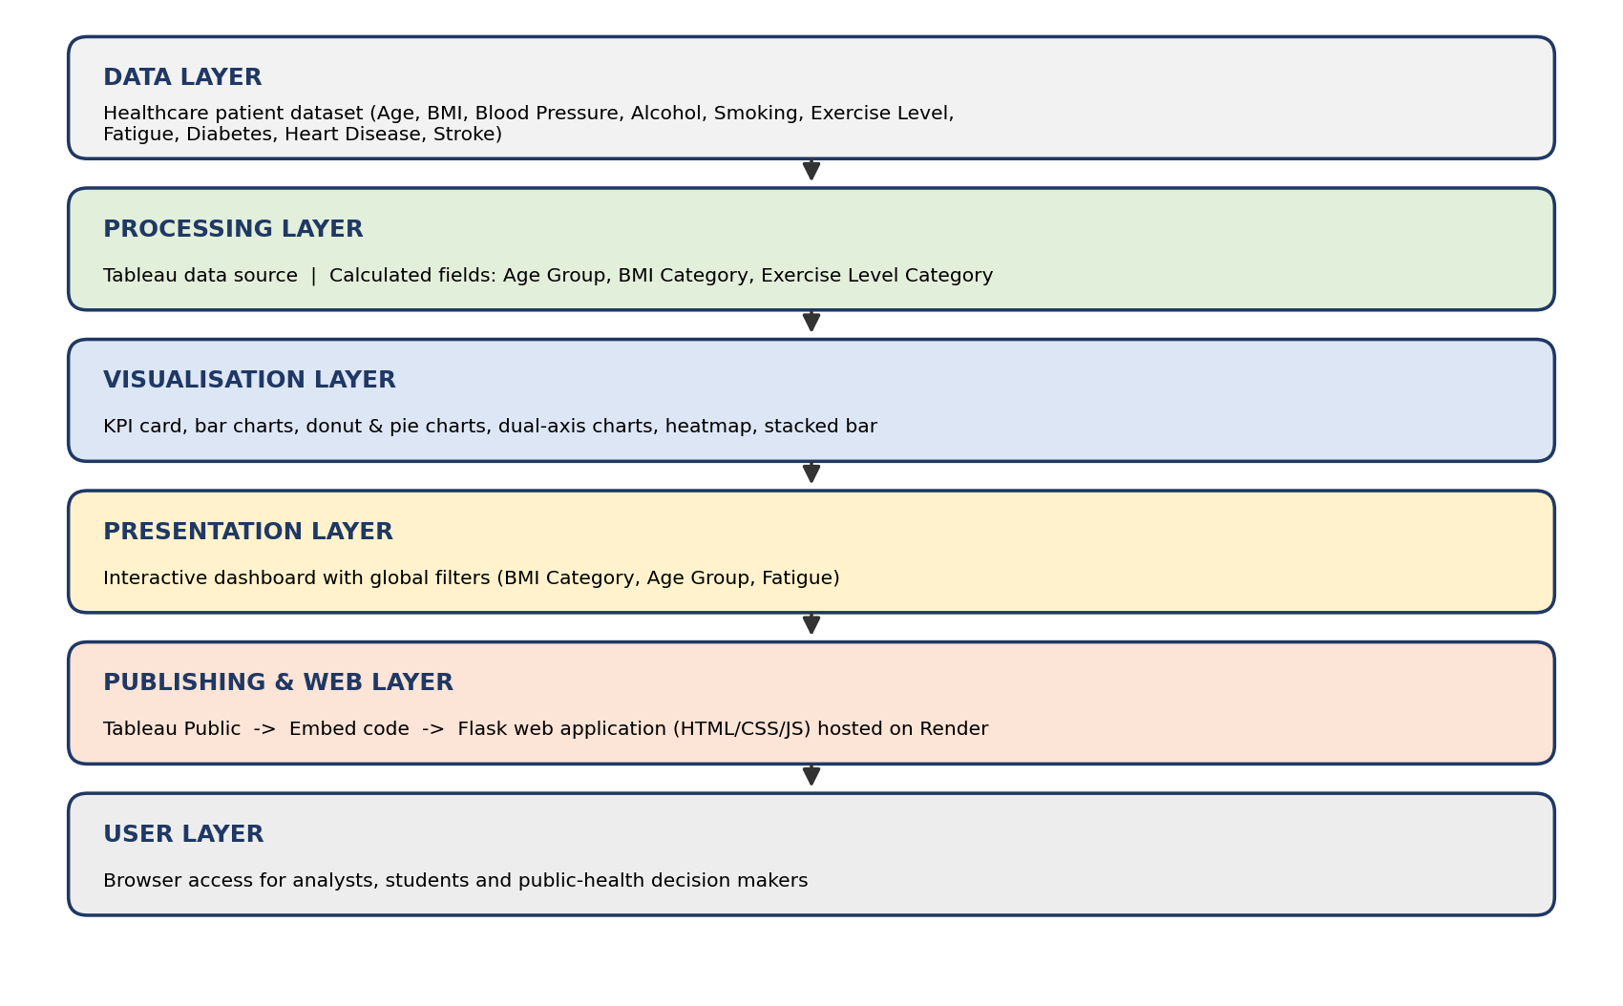
Figure 4.1: Solution architecture of Health360
- Data layer: holds the raw patient dataset.
- Processing layer: Tableau reads the dataset, assigns data types and adds the calculated fields.
- Visualisation layer: each worksheet answers one analytical question using an appropriate chart type.
- Presentation layer: worksheets are assembled in a single dashboard with a title, layout containers and filters.
- Publishing and web layer: the workbook is published to Tableau Public; the dashboard is placed in a Flask HTML template and the application is hosted on Render.
- User layer: users open the web page, read the KPI card, interact with filters and drill into the charts.

5. PROJECT PLANNING & SCHEDULING

5.1 Project Planning
The project was planned in phases so that each phase produces a tangible output that the next phase depends on. An eight-week timeline was used for planning; each week represents roughly the same amount of work.
Phase | Activities | Output | Duration
1. Ideation | Problem statement, empathy map, brainstorming | Selected solution idea | Week 1
2. Requirement analysis | Journey map, functional and non-functional requirements, technology choice | Requirement specification | Week 2
3. Data preparation | Study of dataset, data-type checking, cleaning | Clean data source in Tableau | Weeks 2–3
4. Feature engineering | Create Age Group, BMI Category, Exercise Level Category | Three calculated fields | Week 3
5. Worksheet development | Build KPI card and nine worksheets | Ten Tableau worksheets | Weeks 3–5
6. Dashboard design | Layout, title, filters, formatting | Smart Healthcare and Risk Factor Analysis Dashboard | Weeks 5–6
7. Publishing & web integration | Save to Tableau Public, copy embed code, build Flask page | Public URL and web page | Weeks 6–7
8. Testing | Functional checks, filter tests, accuracy validation | Test report | Week 7
9. Documentation | Screenshots, report writing | Final project report | Weeks 7–8

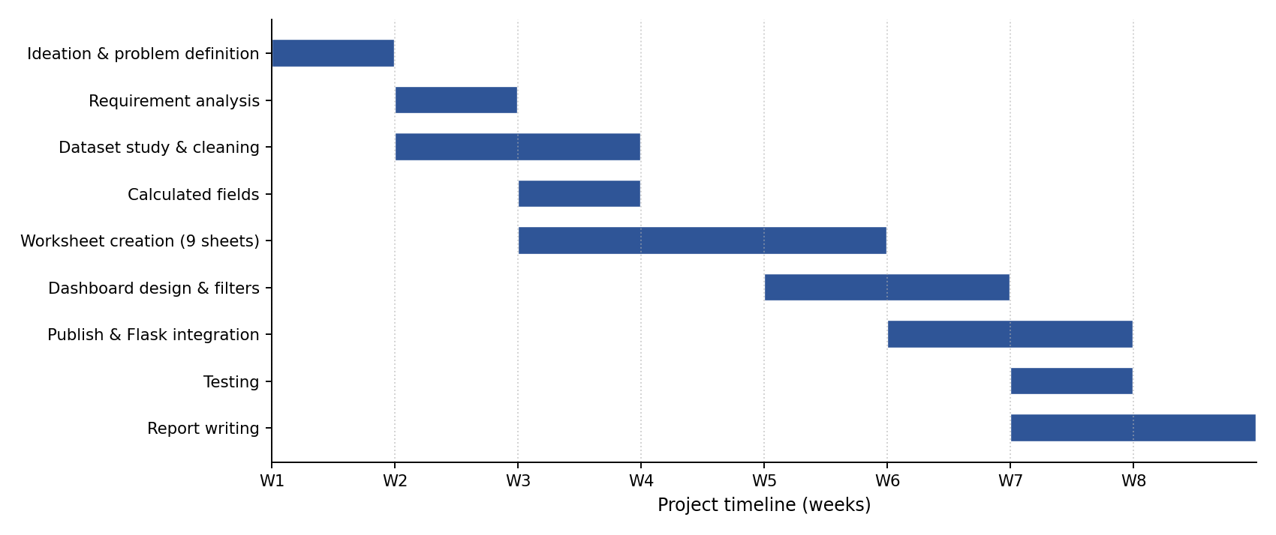
Figure 5.1: Project schedule (Gantt chart)

Risks and mitigation
Risk | Impact | Mitigation
Missing or inconsistent values in the dataset | Wrong totals and averages | Check data types and null values before building sheets
Wrong aggregation (SUM vs AVG) | Misleading charts | Use SUM for counts and AVG for rates; verify against raw data
Filters not applying to all sheets | Inconsistent dashboard | Apply filter to ‘All Using This Data Source’
Embed code blocked by browser or Flask template | Dashboard not visible on the web page | Test the page in multiple browsers; use the official Tableau embed script

6. FUNCTIONAL AND PERFORMANCE TESTING

6.1 Performance Testing
Testing verified that the dashboard is correct (functional testing) and that it responds quickly and consistently (performance testing). The test cases below were designed from the functional and non-functional requirements. The Status column shows Pass for tests that could be verified directly from the final outputs; the remaining tests are marked after execution.

Functional test cases
ID | Test scenario | Steps | Expected result | Status
TC-01 | Data loads correctly | Connect the dataset in Tableau | All columns appear with the correct data types; the record count matches the file
TC-02 | Age Group field | Check records at boundary ages (30/31, 40/41, 50/51, 60/61, 70/71) | Each age falls into the correct band
TC-03 | BMI Category field | Check BMI values 18.4, 18.5, 24.9, 25, 29.9, 30 | Underweight, Normal, Normal, Overweight, Overweight, Obese respectively
TC-04 | KPI totals | Compare KPI values with direct counts from the dataset | Values are identical
TC-05 | Average blood pressure | Compare chart values with manual averages | Values match
TC-06 | Percent-of-total pie | Add all percentages of the pie chart | Sum equals 100% (20.38 + 16.38 + 16.26 + 16.08 + 15.86 + 15.04 = 100.00) | Pass
TC-07 | Heatmap | Hover over a cell and compare its value with the data | Tooltip value equals the average heart-disease rate of the group
TC-08 | BMI Category filter | Select one BMI category on the dashboard | All sheets using the same data source update
TC-09 | Fatigue / Age Group filters | Change filter selections | Related charts update correctly
TC-10 | Tableau Public link | Open the published URL in an incognito window | Dashboard loads without login
TC-11 | Flask embedding | Run the Flask app and open the home page | Embedded dashboard is displayed on the page | Pass
TC-12 | Cross-sheet consistency | Add the fatigue counts of all age groups and compare with the KPI total | Sum equals the total number of patients (5,000) | Pass

Performance test cases
ID | Parameter | Target | Observed value | Status
PT-01 | Dashboard first load time | Within a few seconds on broadband
PT-02 | Filter response time | Charts refresh in about 1–3 seconds
PT-03 | Flask page load time | Page renders without errors, embedded viewer loads
PT-04 | Browser compatibility | Works on Chrome, Edge, Firefox and Safari
PT-05 | Screen-size adaptation | Readable on laptop and tablet

Any defect found during testing – for example a wrong aggregation or a filter not applied to every sheet – was corrected in Tableau and the test was repeated until the expected result was obtained.

7. RESULTS

7.1 Output Screenshots
This section presents the outputs of the project, taken from Tableau Public and from the deployed web application. For each worksheet the screenshot is followed by a short explanation of how to read the chart and by the observations that can be drawn from the actual values shown in it.

7.1.1 KPI Overview
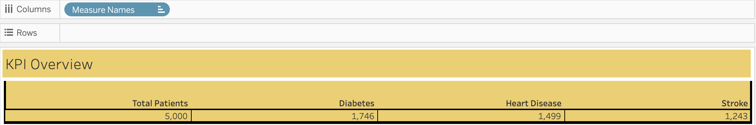
Figure 7.1: KPI Overview
The KPI card is the headline of the dashboard. It shows the total number of patients (COUNT of Age) and the total number of diabetes, heart-disease and stroke cases (SUM of each 0/1 flag), giving the scale of the population and the overall disease burden before any detailed analysis.
Indicator | Count | Share of patients
Total patients | 5,000 | 100%
Diabetes | 1,746 | 34.92%
Heart disease | 1,499 | 29.98%
Stroke | 1,243 | 24.86%

Observation: The dataset contains 5,000 patients. Diabetes is the most common condition with 1,746 cases, followed by heart disease with 1,499 cases and stroke with 1,243 cases. Roughly one in three patients therefore has diabetes, and about one in four has had a stroke.

7.1.2 Average Blood Pressure Across Age Groups
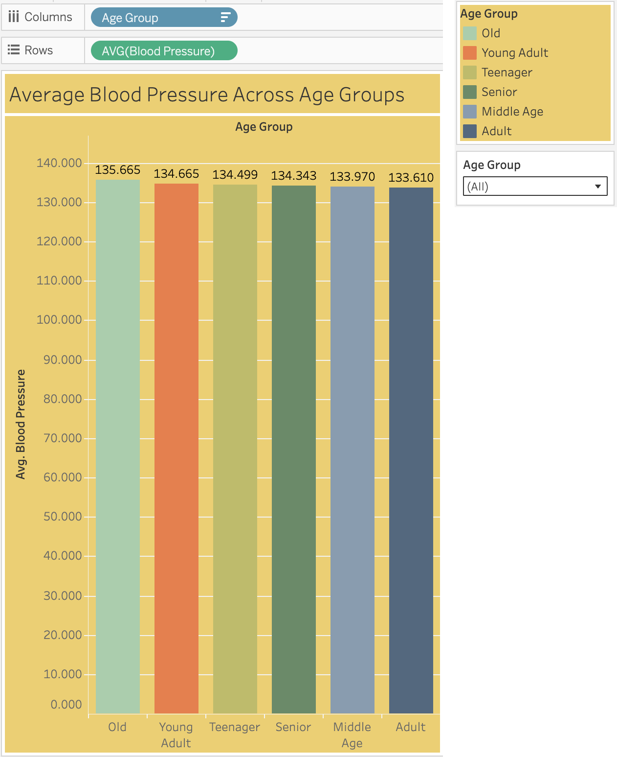
Figure 7.2: Average Blood Pressure Across Age Groups
A bar chart with one bar per age group, coloured by group and labelled with the average blood pressure to three decimal places. Bars are sorted in descending order and an Age Group filter on the right lets the user isolate individual groups.
Observation: Average blood pressure is almost identical in every age group. It ranges from 133.610 (Adult) to 135.665 (Old), a spread of only about two units. The Old group has the highest average, followed by Young Adult (134.665), Teenager (134.499), Senior (134.343) and Middle Age (133.970). In this dataset age alone therefore does not explain large differences in blood pressure.

7.1.3 Alcohol and Smoking Consumption Across Age Groups
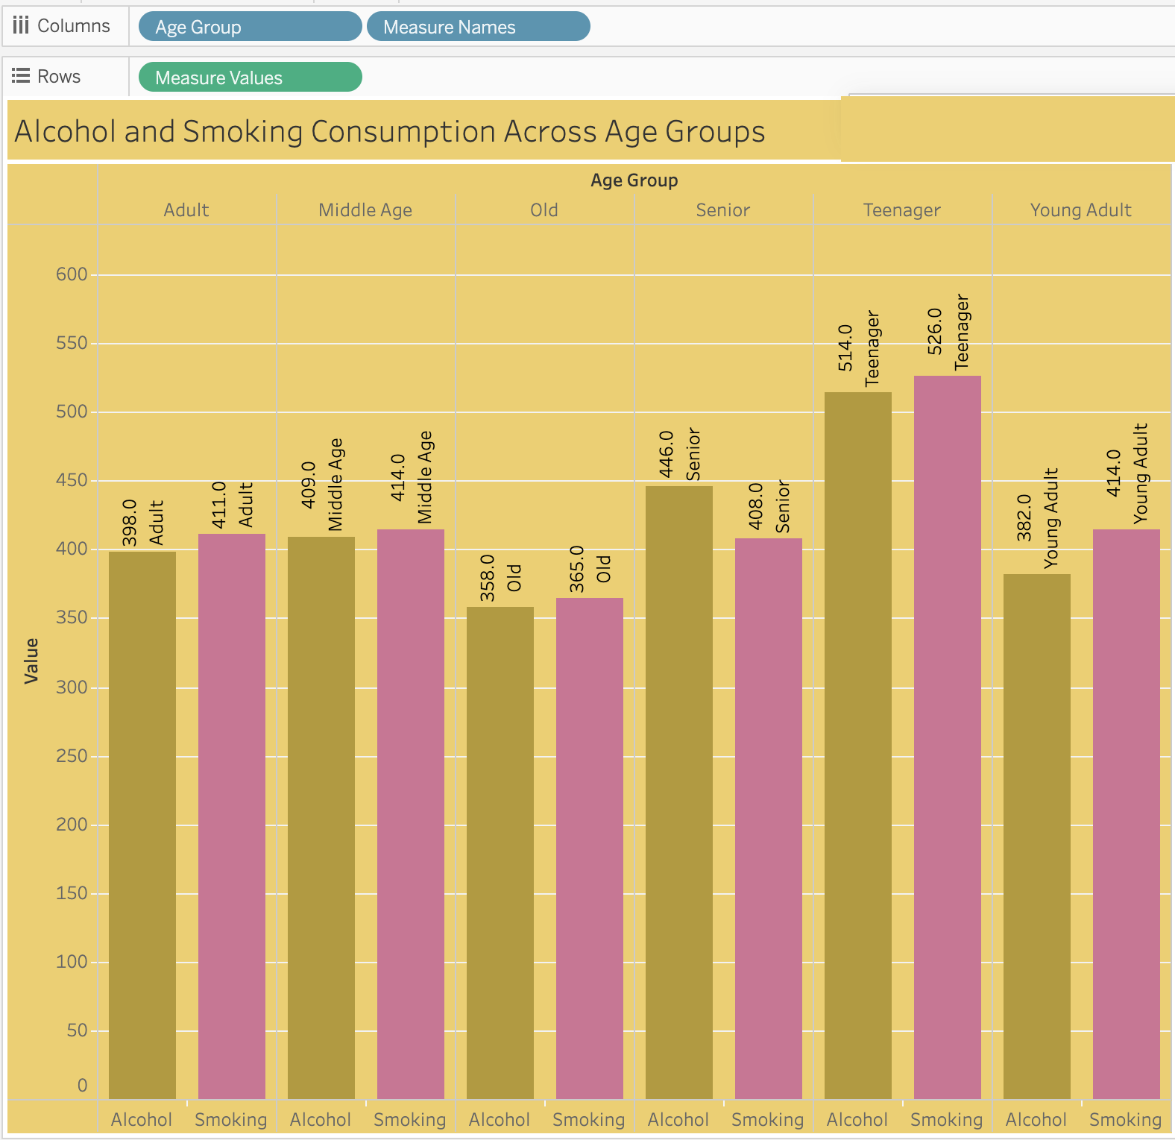
Figure 7.3: Alcohol and Smoking Consumption Across Age Groups
A grouped bar chart (built with Measure Names and Measure Values) that places the total alcohol consumption and total smoking value side by side for each age group, each in its own colour, with the value printed on every bar.
Observation: The Teenager group has the highest totals for both factors (alcohol 514, smoking 526) and the Old group the lowest (alcohol 358, smoking 365). In five of the six groups smoking is slightly higher than alcohol; Senior is the only group where alcohol (446) exceeds smoking (408). Because these are totals (SUM), larger groups naturally show larger bars, and the Teenager group is also the largest group in the dataset.

7.1.4 Exercise Level Distribution
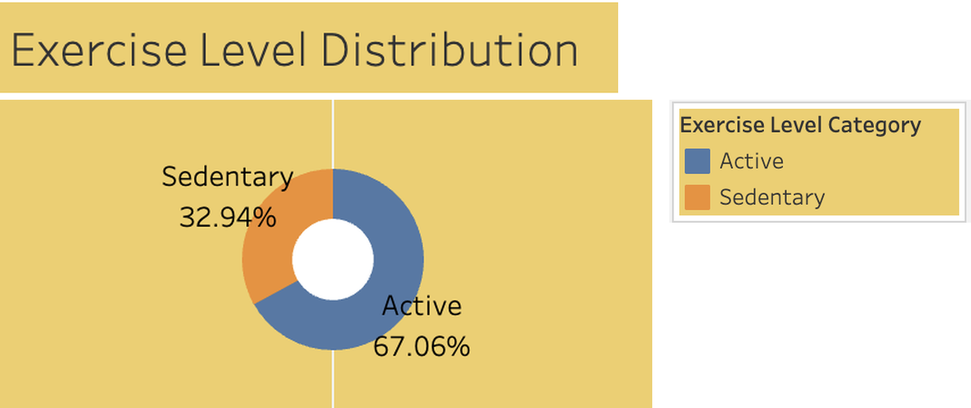
Figure 7.4: Exercise Level Distribution
A donut chart made from a pie chart and a white circle in a dual-axis view. Each slice shows the percentage of patients in an exercise category.
Observation: About two-thirds of the patients are Active (67.06%) and one-third are Sedentary (32.94%). No patient falls into the Moderate band defined in the calculated field, so only two slices appear. Nearly one in three patients having a sedentary lifestyle is a significant lifestyle-risk indicator for the population.

7.1.5 Patient Distribution By Age Group
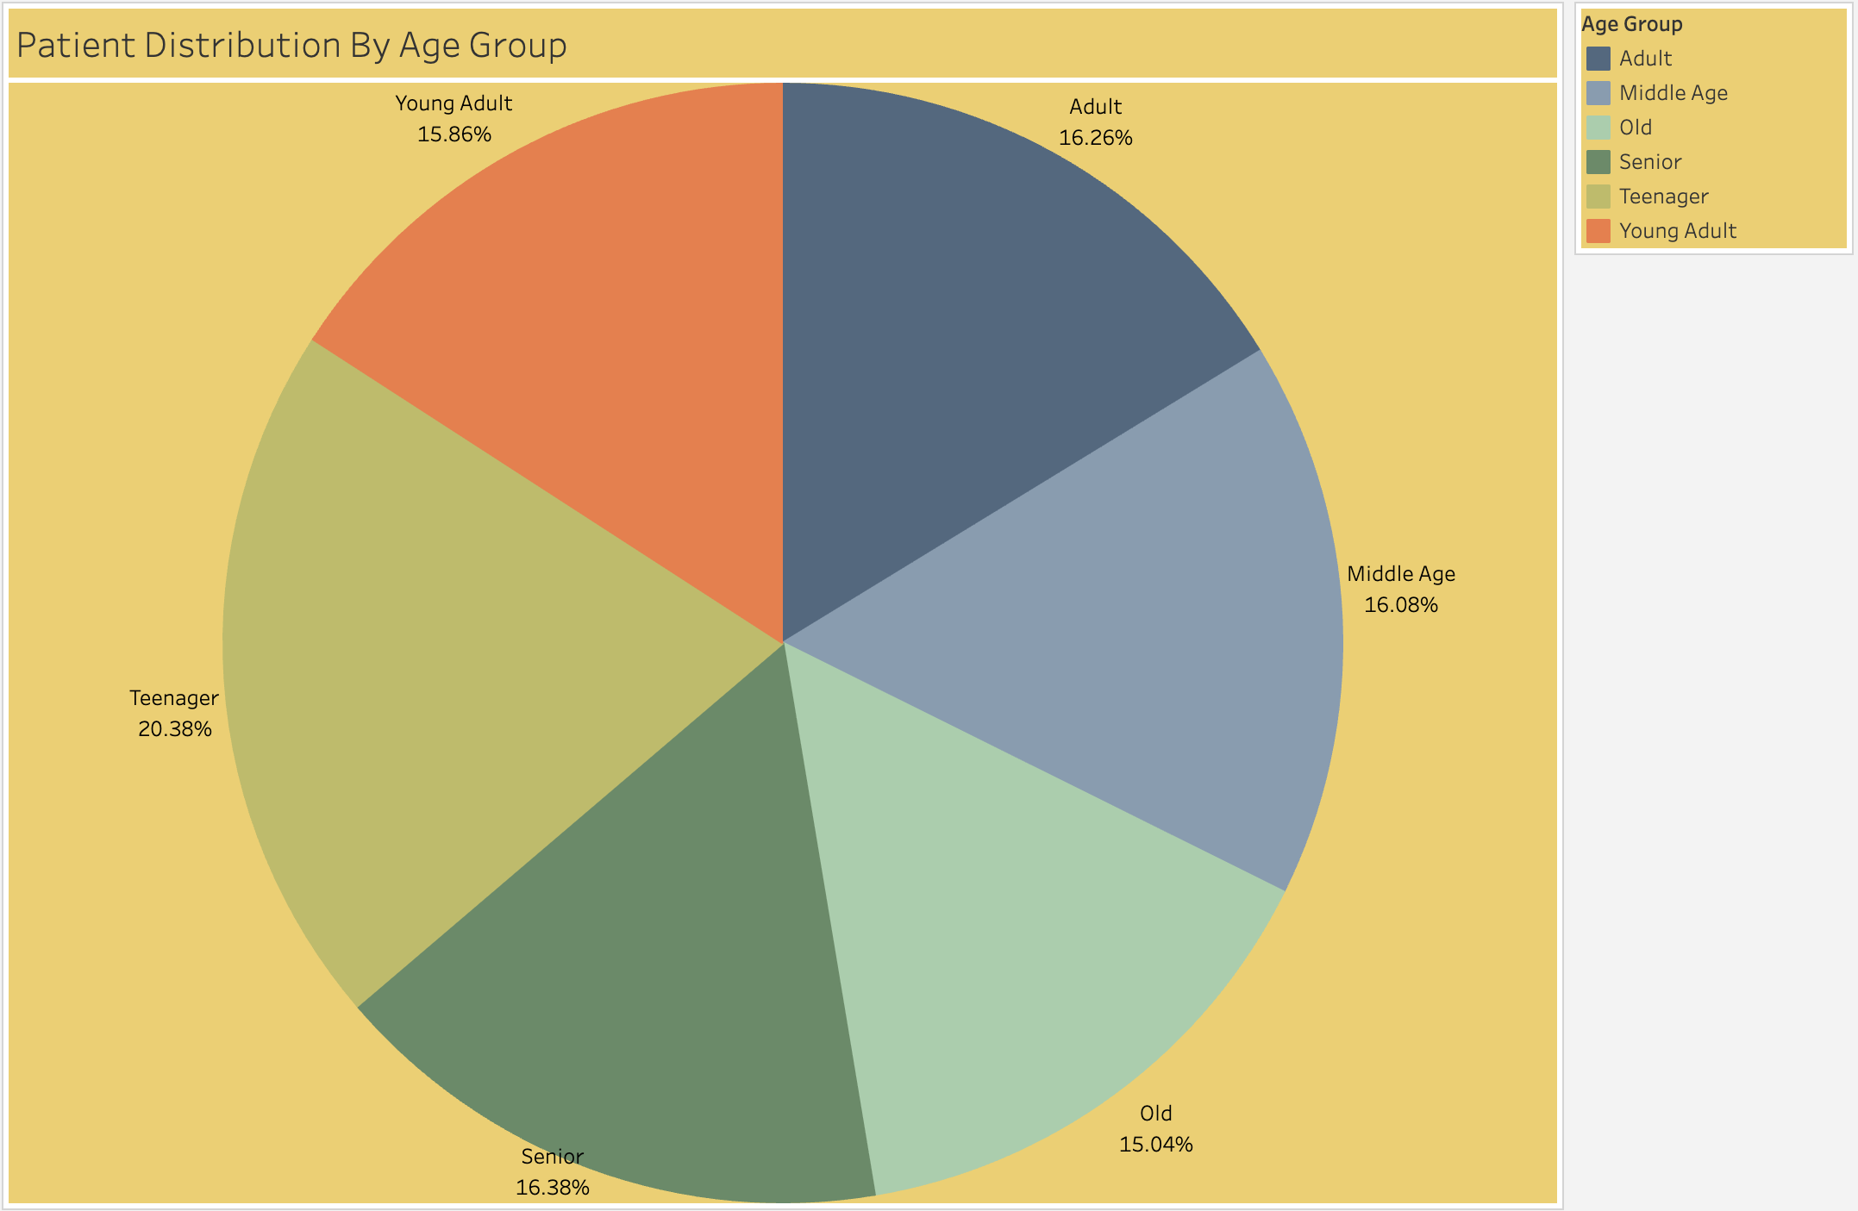
Figure 7.5: Patient Distribution By Age Group
A pie chart in which each slice is the percentage of patients belonging to an age group, calculated with the Percent of Total quick table calculation.
Observation: The population is spread fairly evenly across the six age groups. The Teenager group is the largest with 20.38% of patients; the other groups lie between 15.04% (Old) and 16.38% (Senior): Senior 16.38%, Adult 16.26%, Middle Age 16.08%, Young Adult 15.86% and Old 15.04%. The six percentages add up to 100%.

7.1.6 Heart Disease vs Diabetes Prevalence by BMI Category
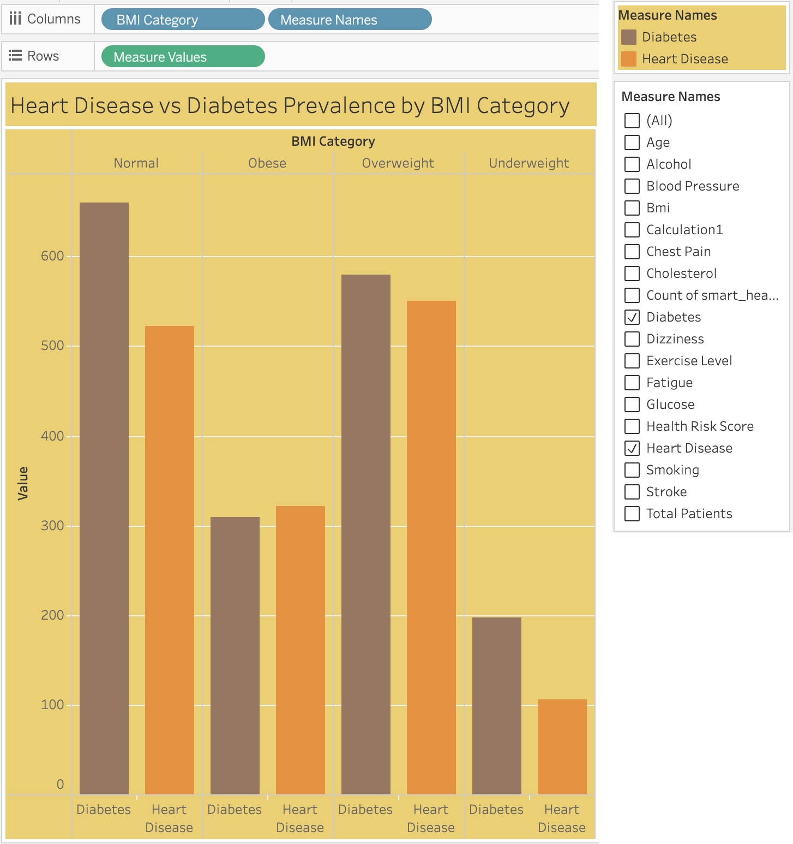
Figure 7.6: Heart Disease vs Diabetes Prevalence by BMI Category
A grouped bar chart that compares the number of diabetes cases and heart-disease cases in the Normal, Obese, Overweight and Underweight BMI categories. Absolute counts are shown, so larger categories show larger bars.
Observation: Reading the bars (the chart is not labelled, so the values are approximate), the Normal category has the largest counts – about 660 diabetes and 520 heart-disease cases – because it is also the largest group of patients. Overweight follows (about 580 and 550), then Obese (about 310 and 320) and Underweight (about 200 and 105). Diabetes cases exceed heart-disease cases in every category except Obese, where the two are almost equal. Counts alone can mislead, which is why the next chart compares rates.

7.1.7 BMI Category vs Heart Disease Rate
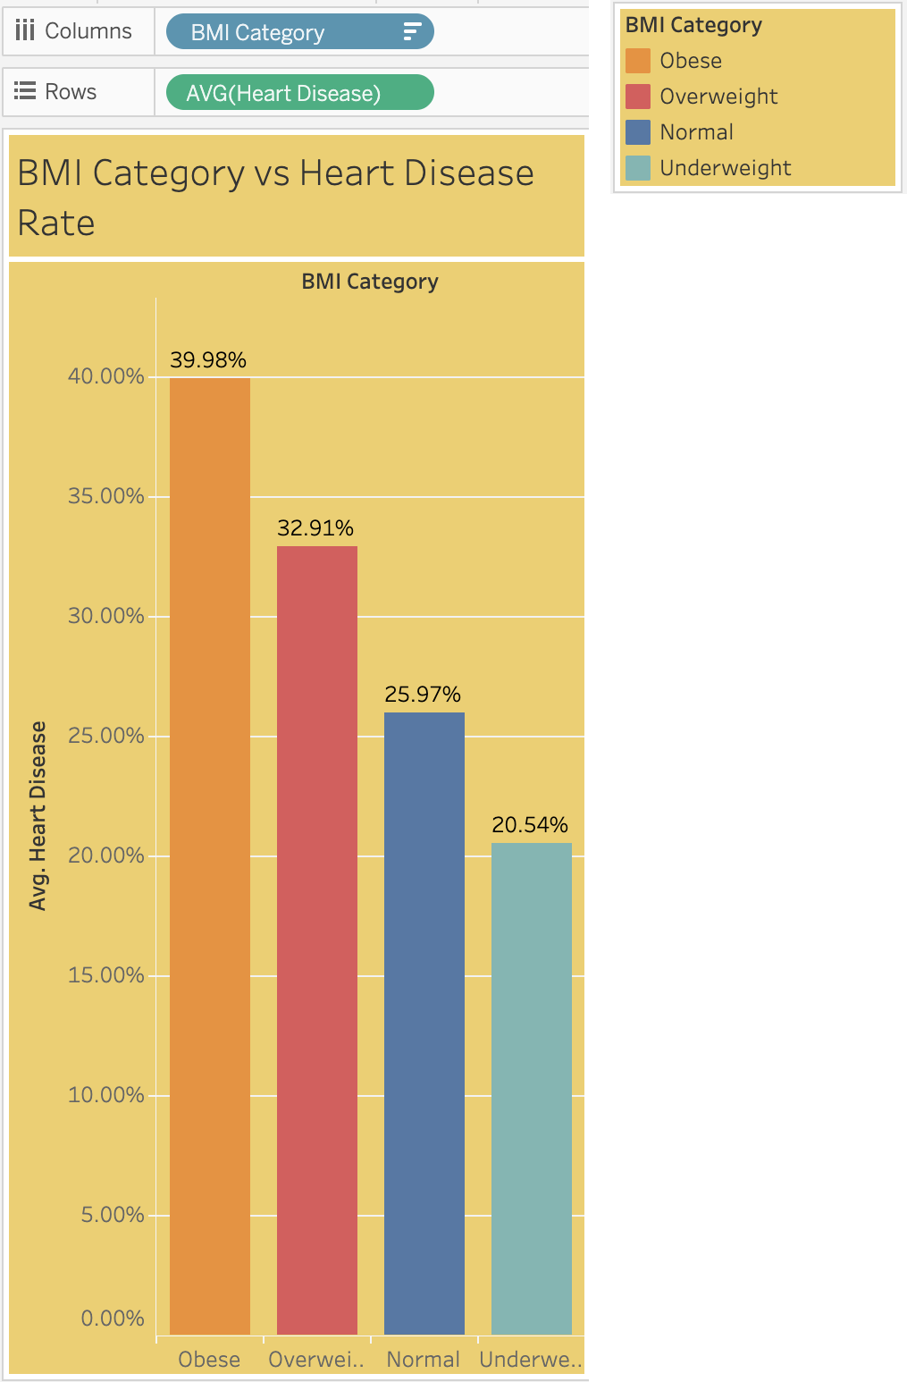
Figure 7.7: BMI Category vs Heart Disease Rate
A bar chart that shows the percentage of patients with heart disease inside each BMI category (AVG of the 0/1 flag, formatted as a percentage). Unlike the previous chart it is not affected by the size of each group, so it is the right chart for comparing risk.
Observation: The heart-disease rate rises steadily with BMI: Underweight 20.54%, Normal 25.97%, Overweight 32.91% and Obese 39.98%. Obese patients are almost twice as likely to have heart disease as underweight patients, and about 14 percentage points higher than patients with normal BMI. This is the strongest pattern in the dataset.

7.1.8 Heart Disease by BMI Category and Exercise Level
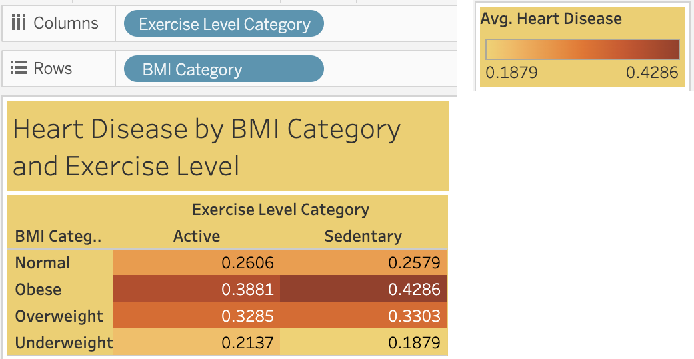
Figure 7.8: Heart Disease by BMI Category and Exercise Level
A heatmap with Exercise Level Category on columns and BMI Category on rows. Each square shows the average heart-disease rate (as a proportion, for example 0.4286 = 42.86%) and darker orange means higher risk.
Observation: The highest risk is in the Obese and Sedentary combination (0.4286), followed by Obese and Active (0.3881). The lowest is Underweight and Sedentary (0.1879). Within the Normal and Overweight categories the Active and Sedentary values are almost the same (0.2606 vs 0.2579 and 0.3285 vs 0.3303), and in the Underweight category the Active value is slightly higher (0.2137 vs 0.1879). The BMI category therefore has a much stronger association with heart disease than the exercise category; exercise shows a visible difference only among obese patients.

7.1.9 Age Group Distribution by Fatigue Condition
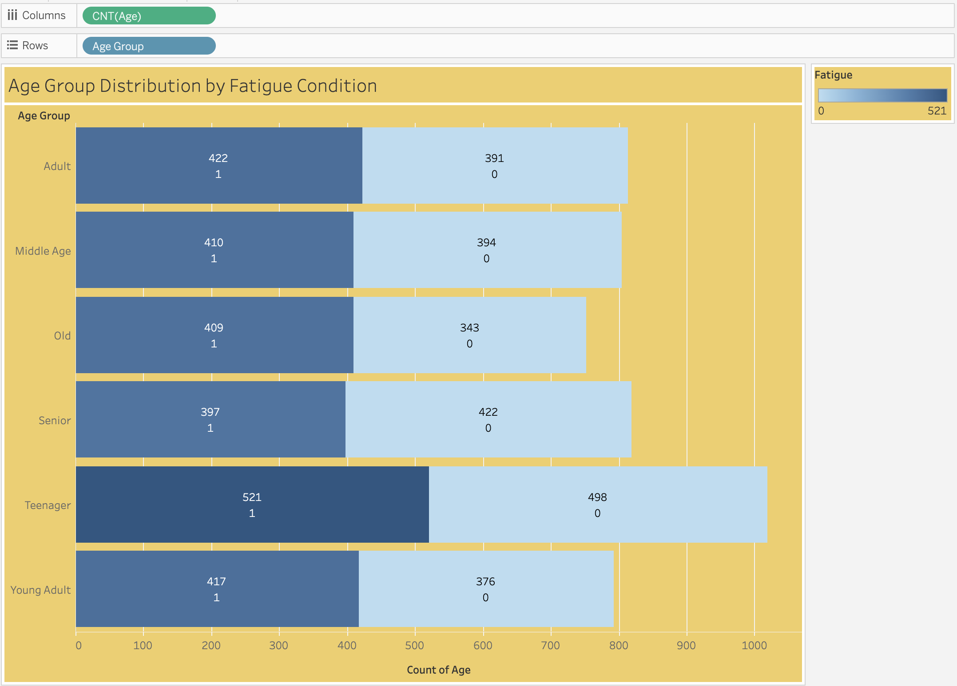
Figure 7.9: Age Group Distribution by Fatigue Condition
A horizontal stacked bar chart with age groups on rows and patient counts on columns, coloured by fatigue (1 = fatigue reported, 0 = no fatigue) and labelled with the count in each segment.
Observation: In total 2,576 of the 5,000 patients (51.5%) report fatigue. The Teenager group has the most patients with fatigue (521) and also the most without (498) because it is the largest group. As a share of its group, fatigue is highest among Old patients (409 of 752, 54.4%) and lowest among Senior patients (397 of 819, 48.5%). Adding the two segments of every bar gives 5,000, matching the KPI total.

7.1.10 Final Dashboard – Smart Healthcare and Risk Factor Analysis Dashboard
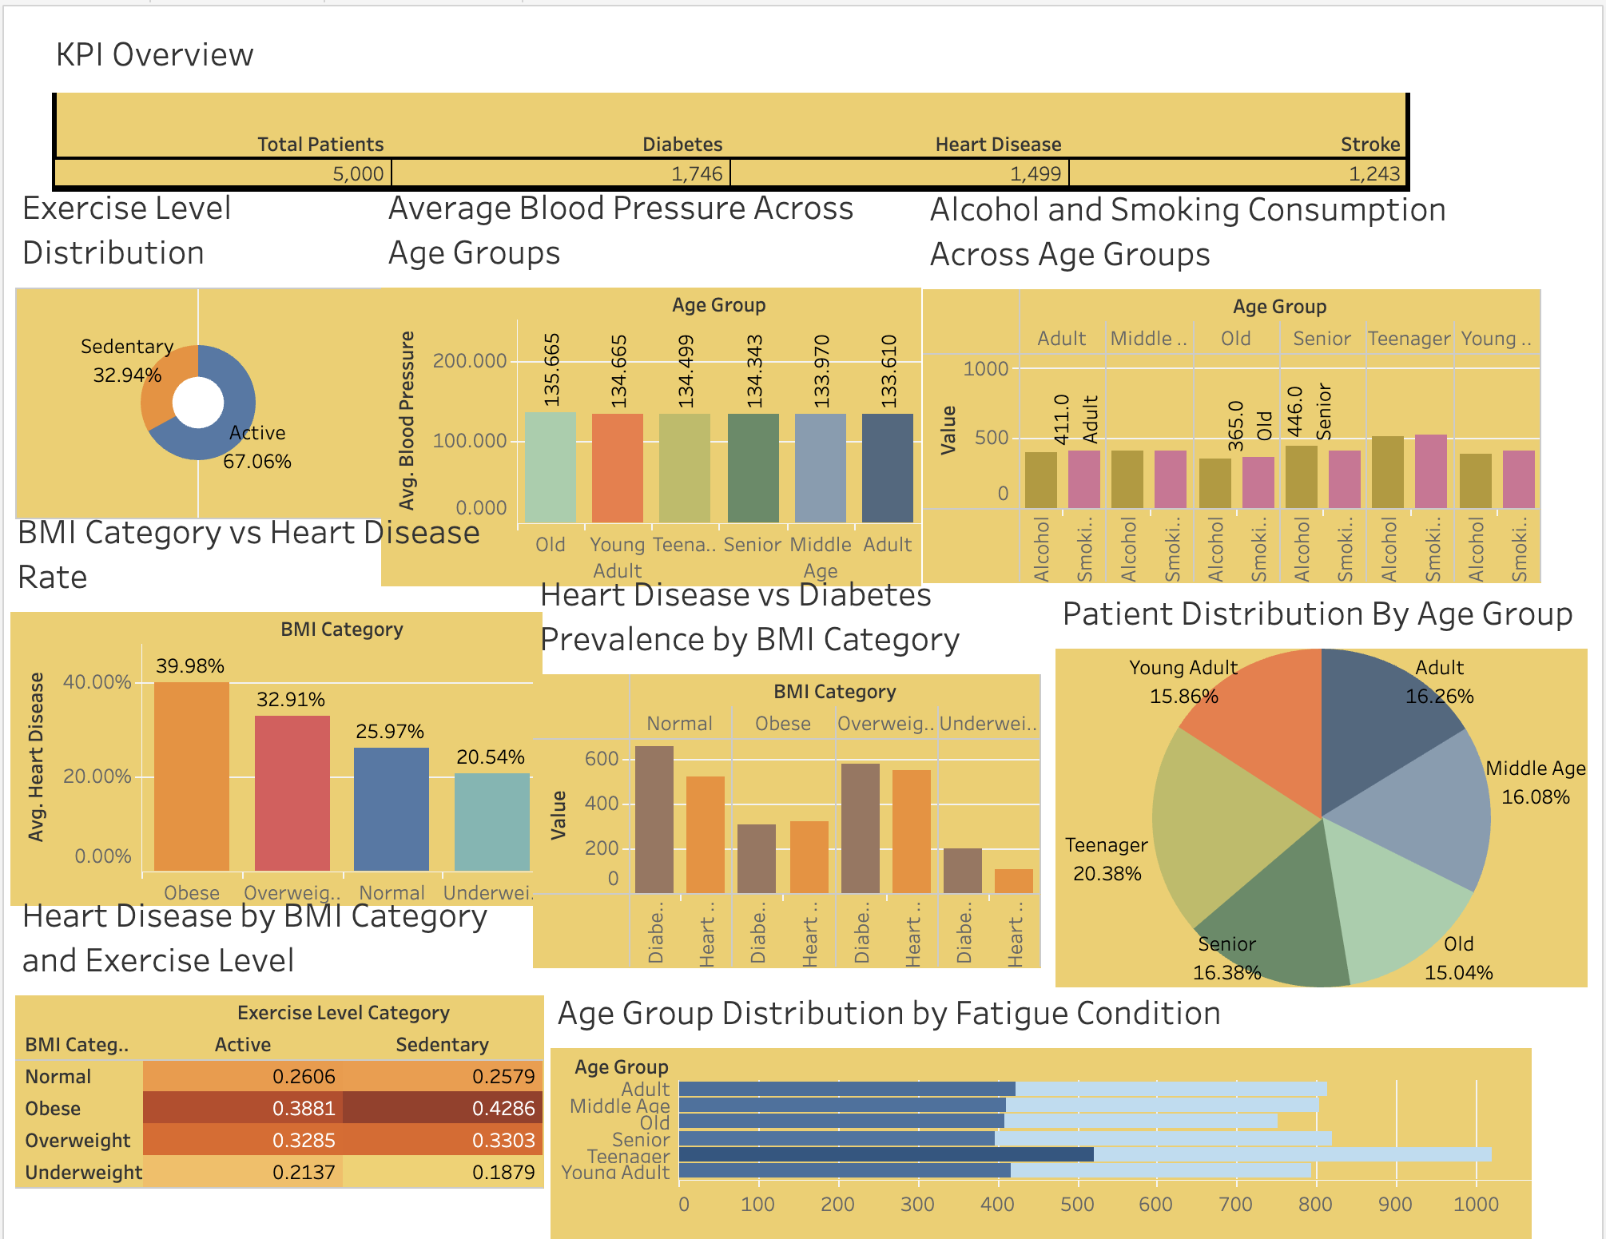
Figure 7.10: Final dashboard in Tableau Public
The final dashboard brings all sheets onto one canvas. The KPI strip is at the top. The second row contains the exercise-level donut, the blood-pressure chart and the alcohol-and-smoking chart. The third row contains the BMI-vs-heart-disease-rate chart, the heart-disease-vs-diabetes chart and the age-group pie chart. The bottom row contains the heatmap and the fatigue chart. Seeing the sheets together allows the reader to move from the overall disease burden to the risk factors and then to the combined effect of BMI and exercise on a single screen.

7.1.11 Dashboard on the deployed web application
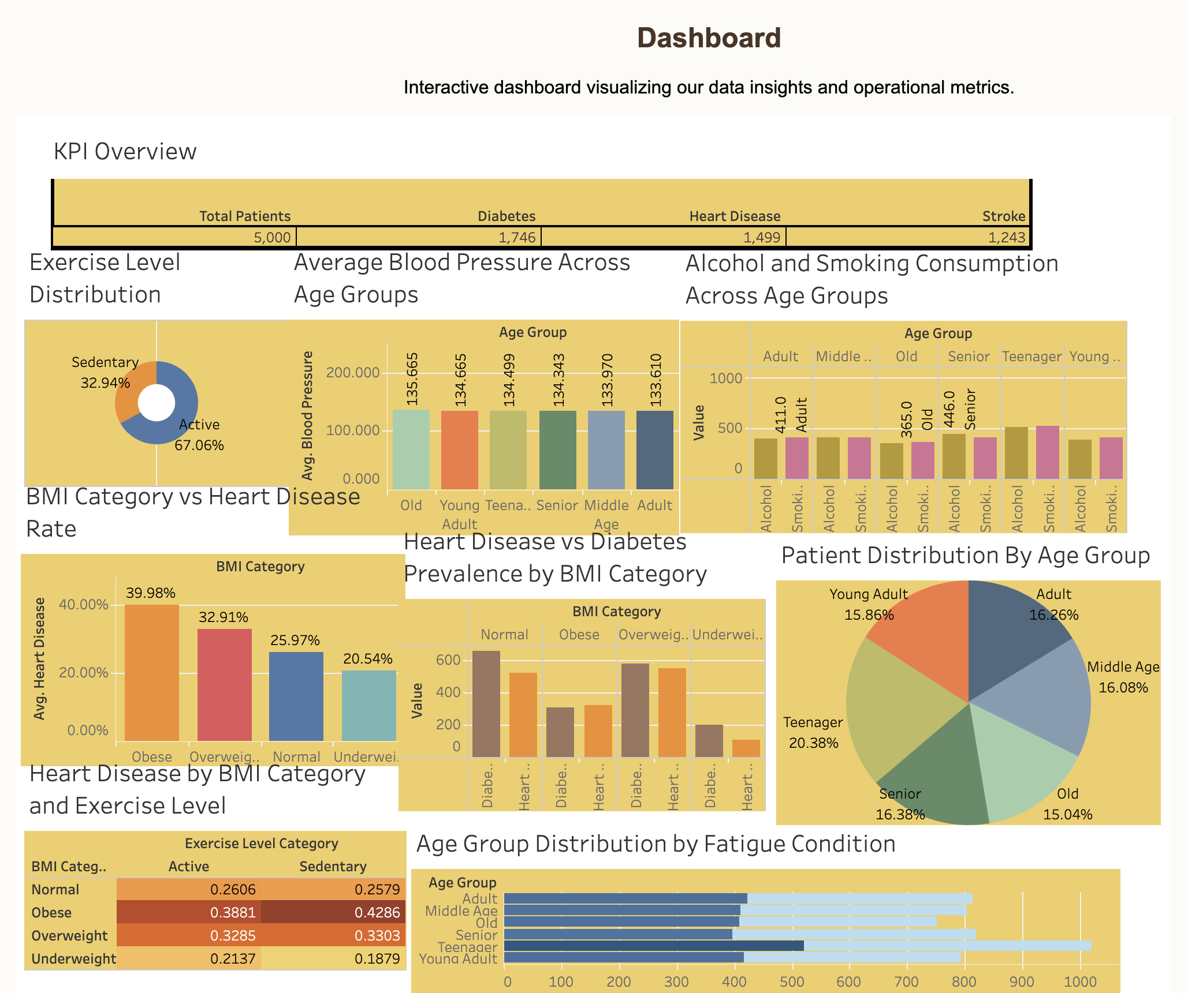
Figure 7.11: Dashboard displayed on the deployed Flask web application (Render)
The same dashboard is displayed on the web page of the Flask application deployed on Render, titled “Dashboard” with the line “Interactive dashboard visualizing our data insights and operational metrics.” The page is publicly reachable at https://final-health-360-project.onrender.com, so the results can be viewed from any browser without Tableau.

Summary of insights
- Disease burden: of 5,000 patients, 1,746 (34.92%) have diabetes, 1,499 (29.98%) have heart disease and 1,243 (24.86%) have had a stroke.
- BMI is the strongest risk factor: the heart-disease rate climbs from 20.54% for Underweight to 25.97% for Normal, 32.91% for Overweight and 39.98% for Obese patients.
- Highest-risk combination: Obese and Sedentary patients have a heart-disease rate of 42.86%, the highest in the heatmap; Underweight and Sedentary patients have the lowest (18.79%).
- Exercise and age show weaker effects: Active and Sedentary rates are nearly equal for Normal and Overweight patients, and average blood pressure stays between 133.610 and 135.665 in every age group.
- Lifestyle and fatigue: 32.94% of patients are sedentary; the Teenager group has the highest alcohol (514) and smoking (526) totals, partly because it is the largest group (20.38%); 51.5% of all patients report fatigue, highest among Old patients (54.4%).

8. ADVANTAGES & DISADVANTAGES

Advantages
- Interactive and visual: users explore the data with filters instead of reading rows of numbers.
- Single source of insight: KPI, distributions, comparisons and heatmap are available on one screen.
- Meaningful categories: engineered fields such as Age Group and BMI Category convert raw values into groups that are easy to interpret.
- No coding required for users: any user can operate the dashboard through clicks and drop-downs.
- Easy sharing: Tableau Public and the Flask page let anyone with a browser view the dashboard.
- Supports preventive healthcare: highlights risk groups so that screening and awareness can be planned early.
- Scalable and reusable: the same workbook can be refreshed with new data and extended with new sheets.
- Low cost: built with Tableau Public, Flask and GitHub, which are free for learning and demonstration.

Disadvantages
- Descriptive, not predictive: the dashboard shows what is in the data but does not predict the risk of an individual patient.
- Correlation, not causation: a visible pattern does not prove that one factor causes a disease.
- Data-quality dependence: results are only as accurate as the dataset; missing values, bias or small groups can mislead.
- Public hosting: Tableau Public workbooks are publicly visible, so real patient data must never be published this way.
- Static data: the workbook does not update automatically unless it is connected to a live data source.
- Dependence on third-party tools: the solution relies on Tableau and an internet connection for viewing.
- Simplified categories: grouping continuous values (for example age bands) hides variation inside each group.

9. CONCLUSION
Health360 successfully demonstrates how a plain healthcare dataset can be transformed into an interactive analytics product. By engineering three categorical fields and building nine focused worksheets, the project makes it possible to examine how age, blood pressure, alcohol, smoking, exercise, BMI and fatigue relate to the prevalence of diabetes, heart disease and stroke.
The final dashboard, titled “Smart Healthcare and Risk Factor Analysis Dashboard”, brings these views together with a KPI summary and global filters, enabling a decision maker to move from an overall picture to a specific high-risk group in a few clicks. Publishing it on Tableau Public and embedding it in a Flask web application makes the work accessible to anyone with a browser.
The project also covered the complete life cycle of a data-analytics solution – problem definition, ideation, requirement analysis, design, planning, implementation, testing and documentation – and gave practical experience in data preparation, calculated fields, dual-axis charts, heatmaps, dashboard design and web integration.
The results show that, in the 5,000-patient dataset, 34.92% of patients have diabetes, 29.98% have heart disease and 24.86% have had a stroke. Body Mass Index emerged as the strongest risk indicator: the heart-disease rate rises from 20.54% in underweight patients to 39.98% in obese patients, and the combination of obesity and a sedentary lifestyle reaches 42.86%. Blood pressure was almost the same across age groups (133.6–135.7), and about one-third of the patients (32.94%) were sedentary.
In summary, Health360 shows that clear visual analytics can support preventive healthcare by showing where attention and resources are most needed. The project is a descriptive foundation on which predictive and real-time solutions can be built.

10. FUTURE SCOPE
Health360 can be extended in many directions:
- Predictive modelling: train machine-learning models (logistic regression, random forest, gradient boosting) to estimate individual risk of diabetes, heart disease and stroke, and embed the predictions in the web application.
- Larger and richer datasets: add variables such as cholesterol, blood glucose, family history, diet, sleep and stress; use multi-hospital or national datasets.
- Live data connection: connect the dashboard to a hospital database or an API so that the figures update automatically.
- Secure deployment: move from Tableau Public to Tableau Server/Cloud or an open-source tool with login, role-based access and data encryption for sensitive data.
- Wearable-device integration: include real-time data such as heart rate, steps and sleep from fitness trackers.
- Alerts and recommendations: notify users when a patient group crosses a risk threshold and suggest preventive actions.
- Geographical analysis: add map views to find regions with high disease prevalence.
- Time-series analysis: track how risk factors and disease prevalence change over months and years.
- Mobile application and multi-language support: make the dashboard available on phones and in regional languages for wider reach.
- Explainable AI: show which factors contribute most to the predicted risk so that doctors can trust the output.

11. APPENDIX

Source Code (if any)
The project was built mainly in Tableau, so the main “source code” consists of the calculated fields. A sample of the Flask application used to serve the dashboard is also included; the complete source code of the deployed application is available in the GitHub repository given at the end of this appendix.

A. Tableau calculated fields
Age Group
IF [Age] >= 18 AND [Age] <= 30 THEN "Teenager"
ELSEIF [Age] <= 40 THEN "Young Adult"
ELSEIF [Age] <= 50 THEN "Adult"
ELSEIF [Age] <= 60 THEN "Middle Age"
ELSEIF [Age] <= 70 THEN "Senior"
ELSE "Old"
END

BMI Category
IF [Bmi] < 18.5 THEN "Underweight"
ELSEIF [Bmi] < 25 THEN "Normal"
ELSEIF [Bmi] < 30 THEN "Overweight"
ELSE "Obese"
END

Exercise Level Category
IF [Exercise Level] = 0 THEN "Sedentary"
ELSEIF [Exercise Level] = 100 THEN "Moderate"
ELSE "Active"
END

B. Sample Flask application (app.py)
from flask import Flask, render_template

app = Flask(__name__)

@app.route("/")
def home():
return render_template("index.html")

if __name__ == "__main__":
app.run(debug=True)

C. HTML template (templates/index.html)
<!DOCTYPE html>
<html lang="en">
<head>
<meta charset="UTF-8">
<title>Health360 - Healthcare Risk & Disease Analytics</title>
</head>
<body>
<h1>Smart Healthcare and Risk Factor Analysis Dashboard</h1>
<!-- Paste the embed code copied from Tableau Public here -->
<div class='tableauPlaceholder'> ... </div>
</body>
</html>

Dataset Link
Dataset used: ______________________________________ (paste the link of the dataset here)

GitHub & Project Demo Link
GitHub repository: https://github.com/kotasthaneananya-dev/Final-Health-360-project
Tableau Public dashboard: ______________________________________
Project demo (hosted web application on Render): https://final-health-360-project.onrender.com

